
MASENO SCHOOL

2026 MOCK EXAMINATIONS.
Kenya Certificate of Secondary Education

Admission No:……...……………………………..Index No: ………………………………………………
Date: …………………………………………..Candidate’s Signature……………...…………………….

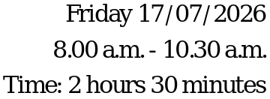451/2
COMPUTER STUDIES
PAPER 2


Instructions to Candidates
- Indicate your name, admission number and stream at the top right of each printout.
- Write your name and admission number on the Exam folder.
- Passwords should not be used while saving in the storage medium.
- Answer all the questions.
- All answers must be saved in your storage medium
- Make a printout of the answers on the answer sheets provided.
- Hand all the printouts and the storage medium.
- Candidates should check the question paper to ensure that all the
- Papers are printed as indicated and no questions are missing.

QUESTION | MAXIMUM SCORE | CANDIDATE SCORE
ONE | 50
TWO | 50
TOTAL | 100

- (a) Figure below displays an excerpt from an Annual Computer contest. Create a workbook using a spreadsheet program and save it as Computer Contest in your folder to print out later. Type the data and format the worksheet as it appears. Use the worksheet to answer the questions below. (Use A4 paper size and Landscape orientation). [14 marks]

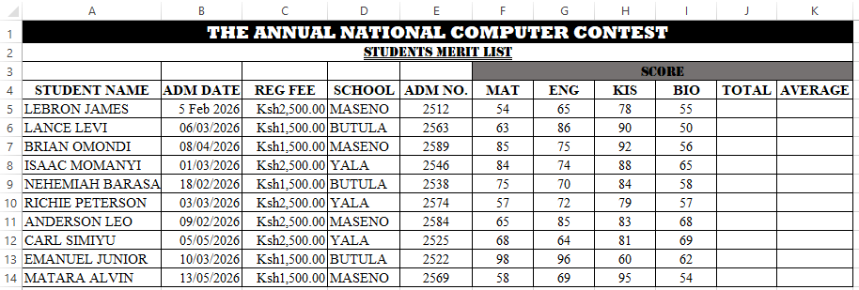
- Rename the current worksheet as Mwejeje. [1 mark]
- Create a new worksheet called Goon-zee in the same Workbook and copy the contests of Mwejeje into it. [1 mark]
From the worksheet named Goon-zee above;
- Calculate the Total and Average mark for each student [2 Marks]
- i. Find the Maximum, and Minimum marks for each Subject. [2 marks]
  - Rename cell range containing the totals as “sum” [1 Marks]
  - Rank the students based on the Average marks. [4 Marks]
  - Sort the students based on position. [2 Marks]

- Insert the school labels in cells D16:D18 and compute the total score contributed by each school for each subject using the appropriate formula. [6 marks]
- Copy the worksheet named mwejeje into a new worksheet and rename it as School Total. Filter the records that meet the criteria indicated below; [4 marks]
SCHOOL | MATHS | Total
Maseno & Butula | Greater than or  equal to 74 | Greater than or  equal to 270

- Create a new sheet called Subtotals and copy the filtered data into it. Create a subtotaled list to display the totaled marks per school. [4 marks]

- To all worksheets enhance data validation rule to all the subjects score, so that it should only accept score between 50 and 100. If you enter the score below 50 an Error message “I am a lazy student” is displayed. [6 marks]
g) (i) Print the Goon-zee worksheet showing the formulas. [3 marks]
  - Print the School totals worksheet.
  - Print the Mwejeje.
- You have been crowned the champion after a designing contest in your school by designing the publication below. Using the appropriate package:



- Set the page size A4 in portrait orientation and design the publication as it appears by considering instructions provided and Save as Apex. [25 marks]
- The title bearing “APEX DESIGNERSCOLLEGE” apply font style Cooper Black and size-18. [2marks]
- The object titled ‘DURATION’ apply solid Fill ‘compound outline-Dark’ [3 marks]
- ‘WHY VISIT US’ shape, apply Center Gradient-Dark. [3 marks]
- Apply font style Castellar, size-22 on WHY VISIT US heading [4marks]
- The ‘ACTIVITIES’ object apply Bevel shape effect “Hard Edge” and Parallel 3-D rotation. Use font type Berlin Sans FB Demi on the text. [4marks]
- Apply Dotted frame within the publication. [2marks]
- Apply double wave underline on the title of your publication [2marks]
- Insert Benefits of designing in two columns using a text box [3marks]
- Apply ‘papyrus texture’ on the background of the publication. [2marks]
- Print the publication. [2marks]

THIS IS THE LAST PRINTED PAGE.

